**Enterprise Needs**

* Every Organization has various infra needs
  + Storage
  + Compute

**Storage Needs**

* Let’s understand Storage Needs of the organizations by the scenarios 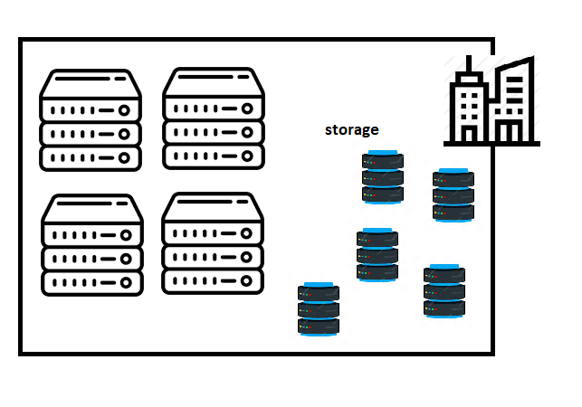
* Let’s classify storage into various different sections
  + Network Storage
  + Server Backup Storage
  + Archive Storage
* Scenario 1: Organization want to save cost on Archival Storage
  + Every cloud gives archival storage at very less cost

That’s the motivation for organizations to move to cloud for at least archival storage. 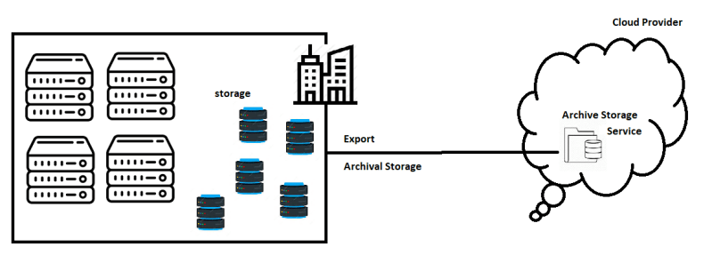

* Scenario 2: Organization wants to move infrequently used backups to Cloud
  + Same as above
* The both scenarios above speak about moving the data into cloud. But for moving what are options which we have
  + Uploading the data using Internet:
    - Advantages: Easy
    - Disadvantage: Unreliable and time consuming
    - Usage: We will use this approach when we are uploading small sizes and this approach will not workout if we use for large sizes of storage
  + Uploading using the Offline Methods
    - Advantages: Good for large storage movements
    - Disadvantage: Costly
    - Usage: When data to be transferred to the cloud is huge and one time.

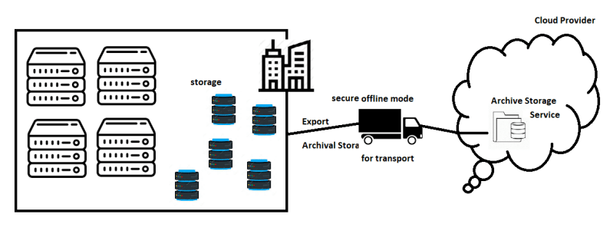

* + Special Hardware Devices:
    - Cloud Provider provides a special servers which can be installed on Cloud Consumers Datacenters and this server will help in synchronizing the data with cloud providers storage.
    - When to Use: Use this mode when daily sync has to happen between cloud and On-Premise

